PROJECT 7
Disaster Tweet Classification
Using NLP & Machine Learning
End-to-end project documentation
Submitted By | Satish Vonteddu
Program | Data Analytics Internship
Organization | NextHikes IT Solutions
Batch | L-110226-W2PM-B15
Submission Date | 15 October 2026

GitHub Repository: https://github.com/vsatish5621/Disaster-Tweet-Classification
Live Application: https://disaster-tweet-classification-baylfnxfscsp4xt4dmffxa.streamlit.app/

1. Executive Summary
This project builds an NLP-based classifier that predicts whether a tweet represents a real disaster-related message or a non-disaster message. The workflow covers text cleaning, exploratory analysis, TF-IDF feature engineering, additional tweet features, model comparison, cross-validation, tuning, evaluation and deployment.
Final selected model: Tuned Multinomial Naive Bayes (alpha = 0.5). Test results: 81.55% accuracy, 83.48% precision, 71.10% recall and 76.80% F1.
Data note: the supplied CSV contains 7,613 rows although the project brief referenced 10,000 hand-classified tweets. All reported results use the supplied dataset.

2. Problem Statement & Objectives
Disaster-related keywords can appear in ordinary or metaphorical messages. The objective is to classify the overall message rather than depend only on keyword matching.
- Clean and prepare tweet text.
- Perform EDA including class distribution, word frequency and sentiment.
- Create TF-IDF and additional tweet-level features.
- Train and compare multiple machine-learning models.
- Use cross-validation and hyperparameter tuning.
- Evaluate the final model and serialize it for inference.
- Provide a simple web application and public deployment.

3. Dataset & EDA
Dataset: twitter_disaster.csv. Shape: 7,613 rows × 5 columns: id, keyword, location, text, target.
Missing values: keyword = 61; location = 2,534.
Target distribution: 4,342 non-disaster (57.03%) and 3,271 disaster (42.97%).
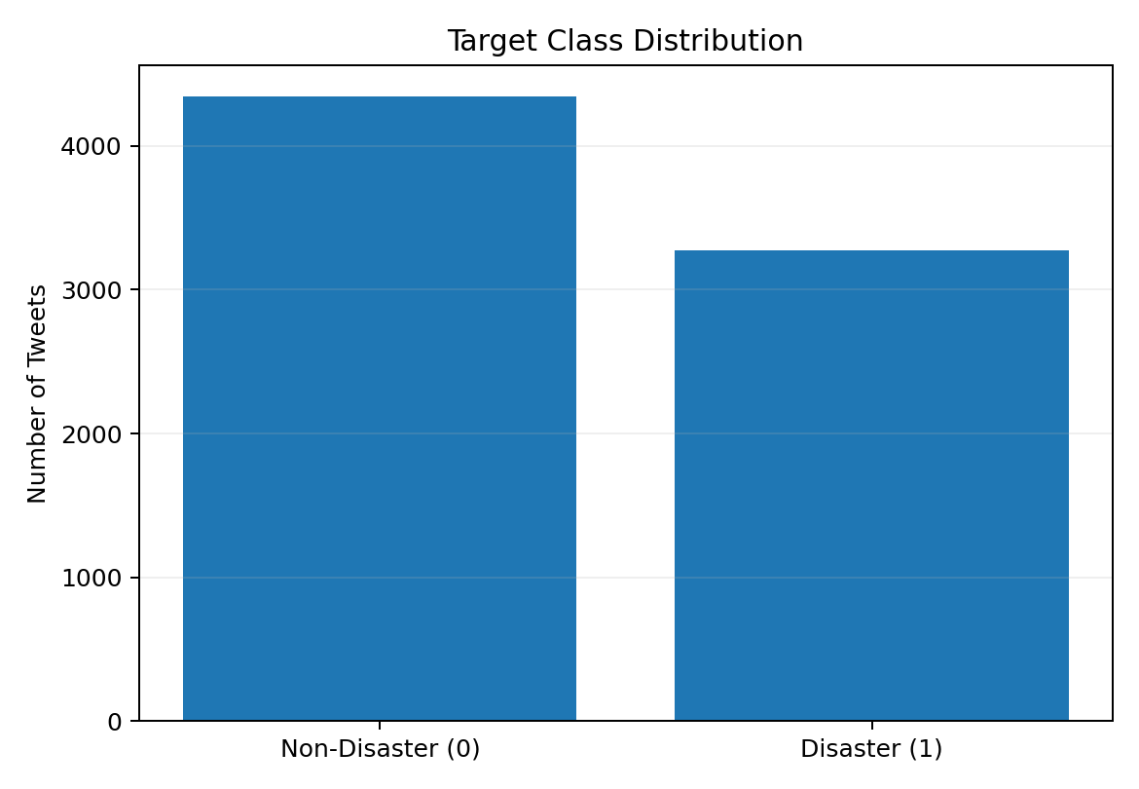

4. Text Preprocessing & Features
- Lowercase conversion.
- URL and HTML removal.
- Newline, punctuation and special-character removal.
- Whitespace normalization.
- Tokenization.
- English stopword removal.
- WordNet lemmatization.
- tweet_len, has_hashtag and has_mention features.
- TF-IDF with max_features = 5,000.
- Final feature space = 5,003 features.
Train/test split: 80/20 stratified split, random_state = 42; 6,090 training rows and 1,523 test rows.

5. Frequent Terms
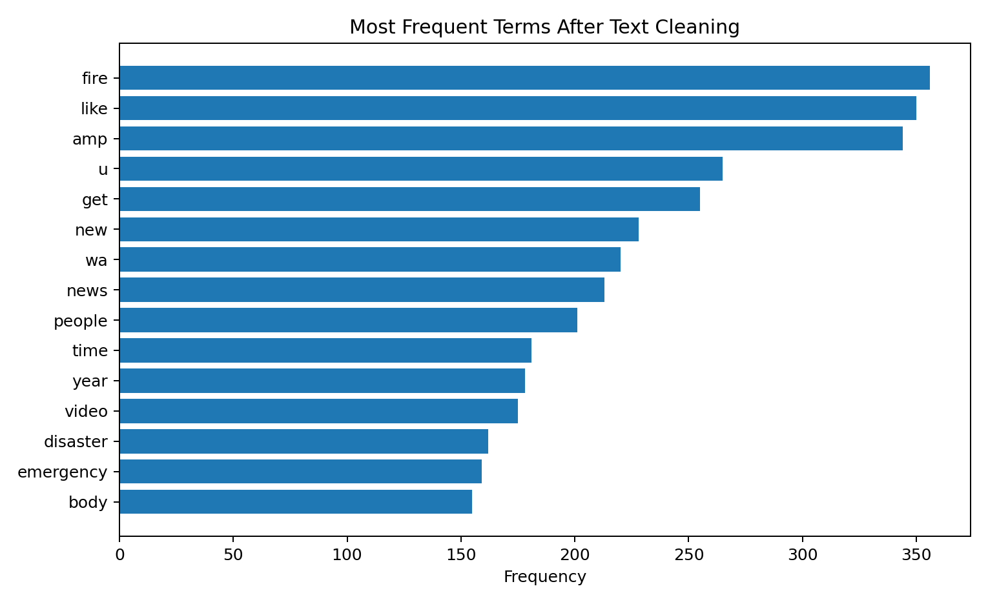
Top cleaned terms included fire (356), like (350), amp (344), u (265), get (255), new (228), wa (220), news (213), people (201), time (181), year (178), video (175), disaster (162), emergency (159), body (155), day (151), home (144), police (143), and building (141).

6. Exploratory Sentiment Analysis
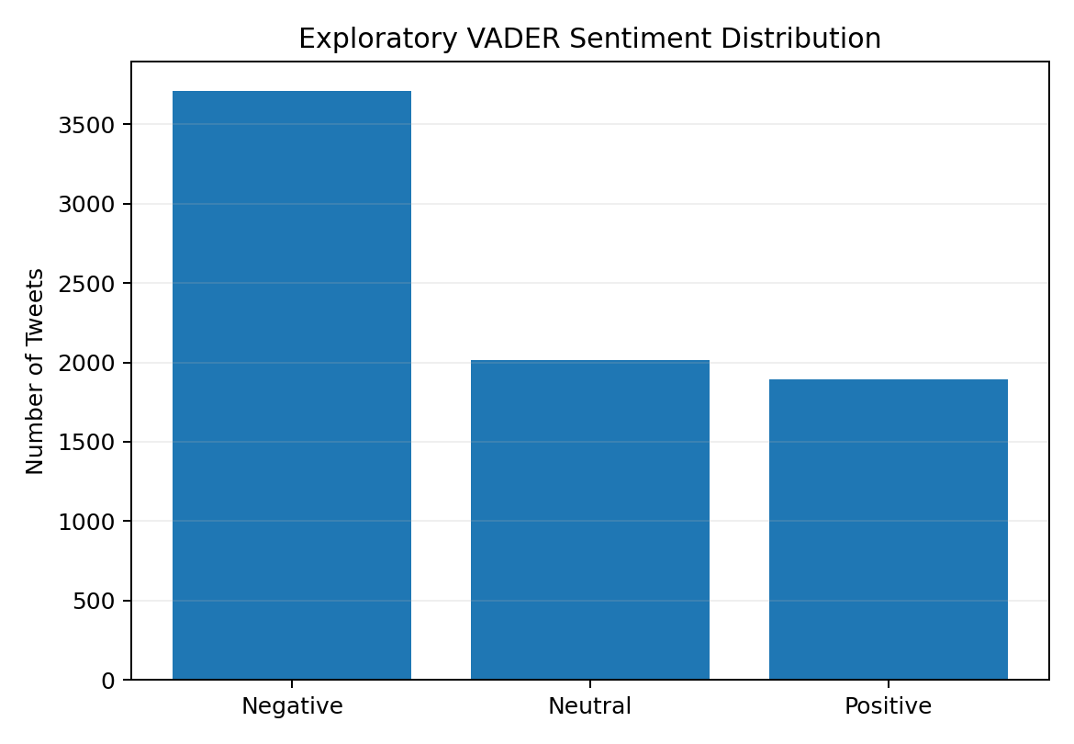
VADER was used for exploratory analysis only: 3,708 negative, 2,012 neutral and 1,893 positive tweets. Sentiment was not added to the final selected model.

7. Model Comparison
Model | Accuracy | Precision | Recall | F1
Logistic Regression | 80.56% | 81.85% | 70.34% | 75.66%
Naive Bayes | 81.81% | 86.04% | 68.81% | 76.47%
Random Forest | 79.97% | 82.99% | 67.13% | 74.22%
XGBoost | 77.74% | 81.31% | 62.54% | 70.70%
Neural Network | 80.89% | 85.38% | 66.97% | 75.06%
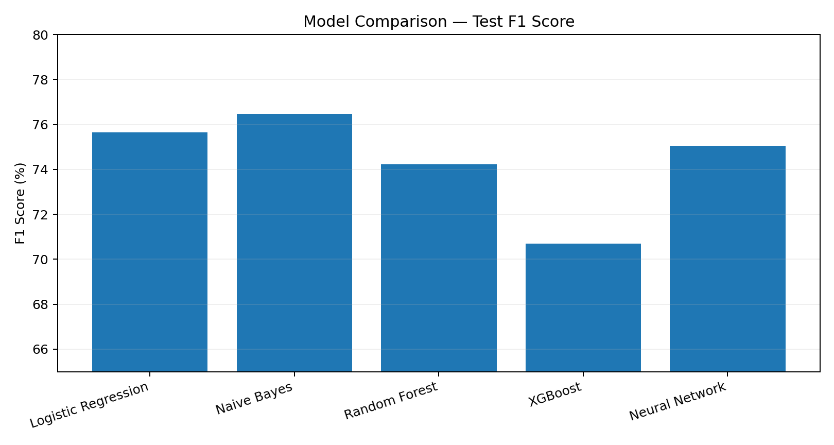

8. Cross-Validation & Tuning
5-fold CV F1: Logistic Regression mean 0.7527 (std 0.0082); Naive Bayes mean 0.7394 (std 0.0144). Logistic Regression tuning tested C = [0.1, 1, 10] and solvers liblinear/lbfgs; best C = 1 and lbfgs, with test F1 unchanged at 75.66%. Naive Bayes tuning tested alpha = [0.01, 0.1, 0.5, 1, 2]; best alpha = 0.5.
Final selected model: tuned Multinomial Naive Bayes.

9. Final Model Performance
Metric | Result
Accuracy | 81.55%
Precision | 83.48%
Recall | 71.10%
F1 | 76.80%
ROC-AUC | 87.27%
Average Precision | 87.28%
Confusion matrix: TN 777, FP 92, FN 189, TP 465.
ROC & Precision–Recall Curves (Final Model)
The uploaded Project 7 notebook contains the original threshold-level outputs used to generate these actual evaluation curves for the tuned Multinomial Naive Bayes model. ROC-AUC = 0.8727 and Average Precision = 0.8728.
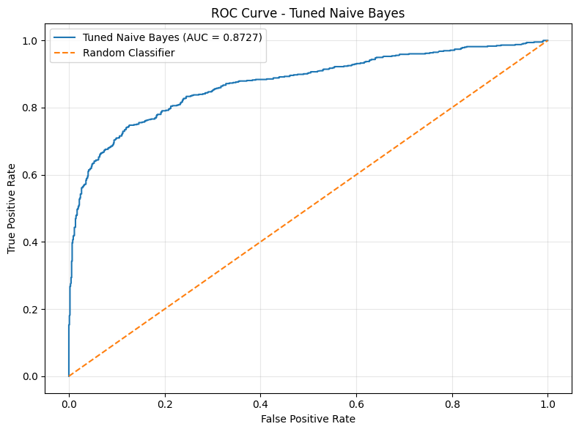
Figure: ROC Curve – Tuned Naive Bayes
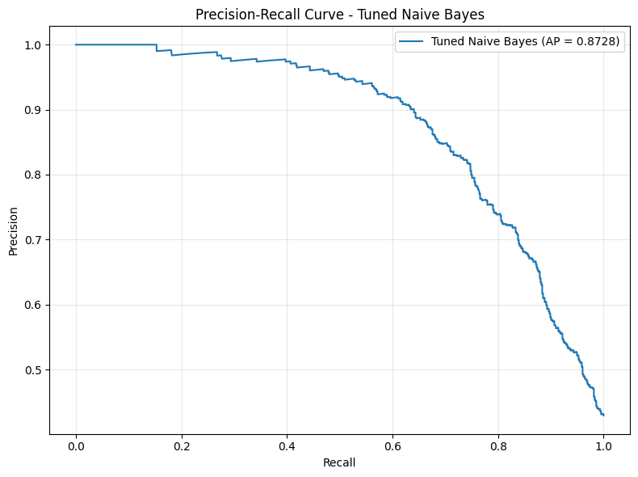
Figure: Precision–Recall Curve – Tuned Naive Bayes

10. Overfitting Check
Training F1 = 0.8382; test F1 = 0.7680; gap = 0.0702 (7.02 percentage points). This indicates a moderate training-test gap.

11. Model Serialization & Validation
- Saved disaster_tweet_model.pkl.
- Saved tfidf_vectorizer.pkl.
- Reloaded both artifacts successfully.
- Colab validation example: “There is a massive earthquake and buildings are collapsing” → Disaster, 83.95% probability.

12. Application & Deployment
A Flask version was tested locally using app.py and Templates/index.html. The final public application uses disaster_classifier_app.py with Streamlit Community Cloud.
Architecture: User Tweet → Preprocessing → TF-IDF + Tweet Features → Serialized Model → Prediction + Confidence → UI.
Deployment Python version: 3.13.
Live URL: https://disaster-tweet-classification-baylfnxfscsp4xt4dmffxa.streamlit.app/

13. Live Validation
- Flood/evacuation example → Disaster Tweet, 93.14% confidence.
- Metaphorical cooking example → Non-Disaster Tweet, 79.69% confidence.

14. GitHub Repository Structure
- README.md
- disaster_classifier_app.py
- app.py
- Templates/index.html
- disaster_tweet_model.pkl
- tfidf_vectorizer.pkl
- requirements.txt
- .gitignore
- .python-version
- LICENSE
GitHub: https://github.com/vsatish5621/Disaster-Tweet-Classification

15. Technical Limitation
TF-IDF was fitted before the train/test split in this project run, creating mild data leakage. Therefore the reported metrics should not be described as a strictly leakage-free benchmark. A future scikit-learn Pipeline should fit TF-IDF only on training data within each validation fold.

16. Future Improvements
- Use a leakage-free Pipeline and stronger validation.
- Experiment with Word2Vec/GloVe or transformer embeddings.
- Tune class weights and decision thresholds for higher disaster recall.
- Perform deeper error analysis on ambiguous tweets.
- Add richer UI analytics and prediction history.
- Evaluate on an external unseen dataset.

17. Requirement Coverage
The project covers EDA/preparation, text cleaning, tokenization, train/test split, word-frequency analysis, TF-IDF, sentiment exploration, additional tweet features, five model candidates, cross-validation, tuning, accuracy/precision/recall/F1, confusion matrix, ROC-AUC, average precision, serialization, Flask local UI, Streamlit deployment, GitHub submission and live validation.

18. Conclusion
The completed project demonstrates a practical end-to-end NLP classification workflow. The tuned Multinomial Naive Bayes model achieved 81.55% test accuracy and 76.80% F1 and was successfully integrated into a public Streamlit application. The documented leakage limitation provides a clear path for improving the next iteration.

Submitted by Satish Vonteddu | Data Analytics Internship | NextHikes IT Solutions | Batch L-110226-W2PM-B15 | 15 October 2026

